**Testbed User Manual for the MADROB benchmark**

The Madrob active door for autonomous robot benchmarking is used for testing the ability of a robot to open a door and pass through it. Testing this ability is done through emulating the looks and feel of a real door, while being able to record data from different sensors: proximity sensors of top of the door, load cell in the handle and encoder on the rotating axis of the door hinges. The structure is made of two main elements: The door assembly frame, which will be rigidly connected to a wall and holds a box with all the electronic components needed for the execution of the benchmark procedure: a raspberry pi, a controller and the motor. The second part of the structure is the movable door frame that can be opened by the robot. The testbed is also able to apply a torque to the handle by transferring the force from the motor to the door through a belt and a gear. This allows the emulation of different situations based on which force profile is specified. The behaviour is selected by the controller which allows for the door to be free, constantly under a braking force or under the effect of a sudden force. All these different behaviours are possible because of the controller that manages the power input of the motor. The behaviour of the door is only passive: it will never move on its own for safety reasons since it could easily harm a human or damage a robot. The motor will apply a torque to the door panel by reading the opening angle of the door and looking in a table (called Look Up Table, LUT for short) for the corresponding force to be applied. Furthermore, most elements can be interchanged to give more variability to the test: the direction in which the door opens, the colour of the cover panels and the type and colour of handles. All these possible variations can be used to have many variations of the benchmark procedure. The system is controlled by Robot Operative System (ROS) which manages messages from the elements that are recording, and also allows for services to be used to set the type of behaviour for the door.  
This document will contain all the information and clarifications needed to build and operate the Madrob Hinged Door testbed. The first section will contain a detailed description of all the components included in the Madrob Hinged Door, it will also explain how they work with one another to implement the benchmark. The second section of this document will explain the procedure to be followed to start the benchmark and eventually which changes can be done both in software and hardware to differentiate the benchmark on different runs.

Table of Contents

1. Component Description 2

1. External Assembly Frame 2

2. Door Assembly 3

3. Door Frame 4

4. Handles 7

5. Lock Mechanism 7

6. Load Cell 7

7. Panels 7

8. Direction locks 7

9. Motor and Gear 8

10. Computer 9

11. Encoder 9

12. Laser Proximity Sensors 9

13. ROS 9

1. Ros Topics 9

2. Ros Services 10

2. User guide 11

1. Calibration 12

1. Load Cell Calibration 12

2. Motor Calibration 12

3. Encoder Calibration 12

2. Bagging 12

3. Benchmarks 13

1. No Lock 13

2. Lock Mechanism (STANDARD BENCHMARK) 13

3. Opening the door against a constant force 13

4. Opening the door against a sudden force 13

5. Opening the door against a moderate wind 14

4. Variance in the Benchmarks 14

5. LUTs 14

1. No Force LUT 14

2. Constant force LUT all range 14

3. Constant force LUT sudden 15

4. Sudden ramp LUT 15

5. Wind Ramp LUT 15

3. Links 16

# Component Description

There are several components that comprise the Madrob Hinged Door and in this section of the document they will be described in detail in their materials, dimensions and features.

## Naming Conventions

Before starting to describe the components, it is important to define the naming conventions used in the following pages

* **Clock-wise** (CW) and **counter Clock-wise** (CCW) directions are considered while looking at the door from the top, according to the following picture (CW direction is the one where the box with electronics is):

CCW

CW

* **Positive angles** are the one going in the CCW direction  
  **negative angles** are the ones in the CW direction according to the right-hand rule  
  **Zero angle** is when the door is in the closed position  
  The angles can vary from -90 degrees to +90 degrees.
* **Positive forces** are the ones pushing towards positive angles so forces that move the door in the CCW direction  
  **negative forces** push toward the CW direction.
* **Assembly Frame** refers to the part of the structure that will be connected to the wall and as such is stationary.
* **Door Frame** refers to the swinging part of the structure that emulates the door. It is connected to the Assembly Frame.
* The proximity sensors are named based on the side on which they are, CCW or CW and their position, left or right according to the following picture:

CCW Right

CCW Left

CW Right

CW Left

## External Assembly Frame

This external frame is the part of the structure that will be encased in the wall to which all the other parts of the assembly connect to. It is made of the 40mm x 40mm aluminium profiles[1] with an 8mm hole in the middle from item24. Its dimension and construction are the ones reported in the following image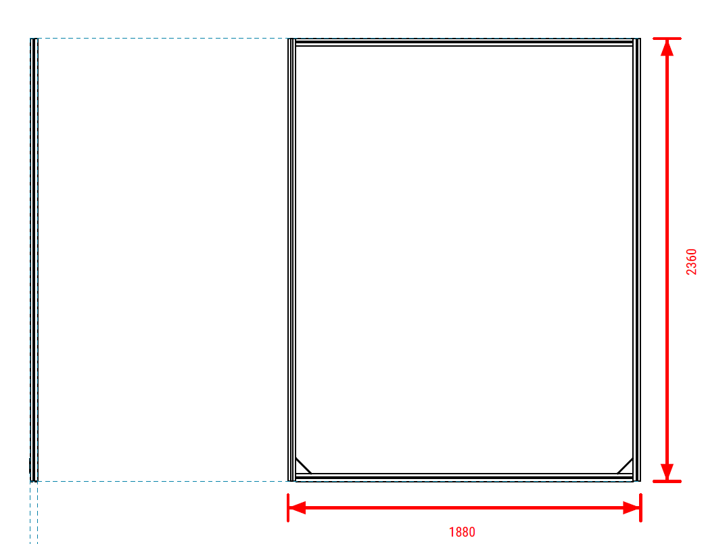

Under here is the list of all the components of the external assembly frame.

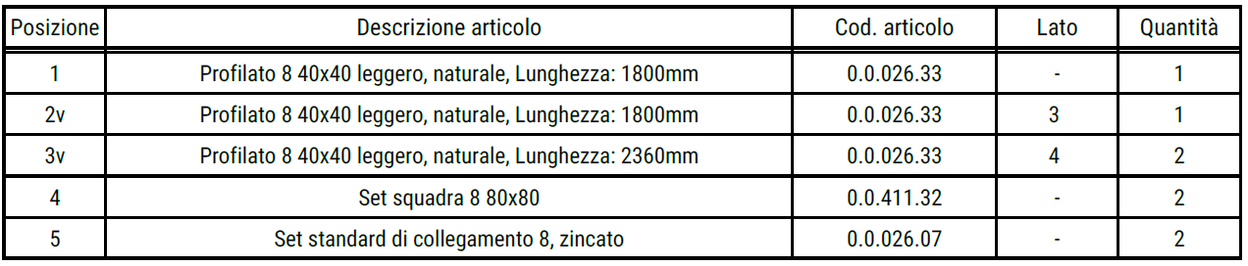

## Door Assembly

This is the structure that will be connected to the External Assembly Frame and that will hold the Door Frame, Motor, Gear and Panels. It is made of the same 40mm x 40mm profiles as the previous frame and has the dimensions and disposition reported in the following image.

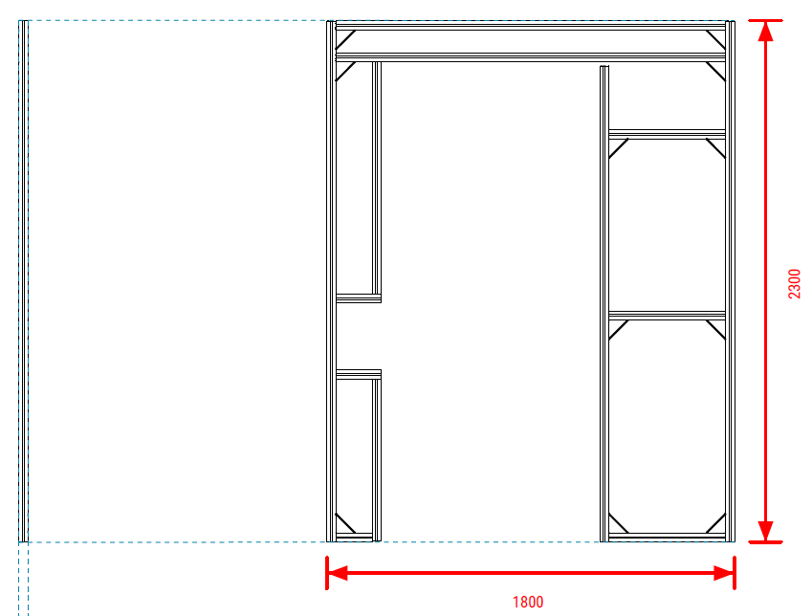

The two horizontal profiles held in position by angled brackets on the right side can be places at any height based on where a structural reinforcement is needed.   
The list of all components of the Door Assembly is at the end of the next chapter, the Door Frame.

## Door Frame

The door frame is the structure made of the same 40mm x 40mm profiles that simulates a real-life door. It connects to the Door Assembly with three heavy-duty hinges. The top and bottom hinges are connected close to the edge of the door while the remaining one is roughly at the middle. The following image represents the dimensions and the structure of the Door Frame.

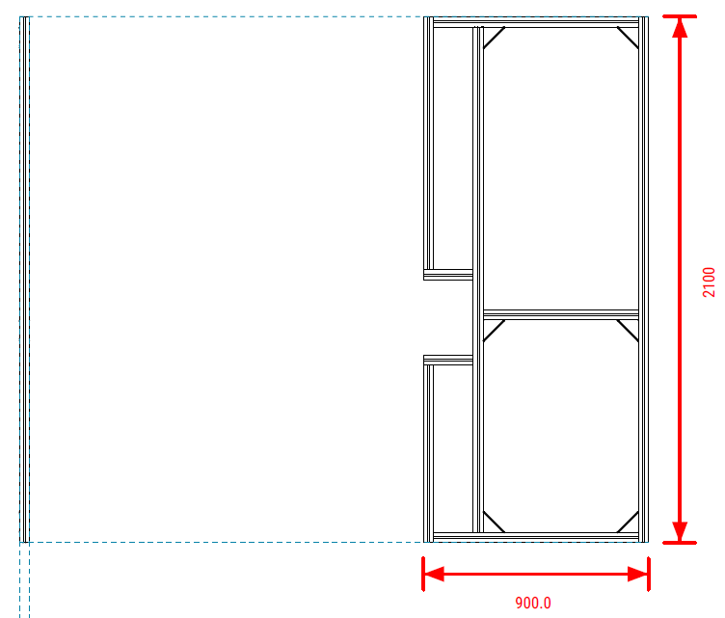

The horizontal profile supported by two angled brackets can be placed at any height, but it is advised to be placed at the same level of the handle in order to better transfer the force applied by the robot to the hinges. The full list of components necessary to build the Door Assembly and the Door Frame is reported here.

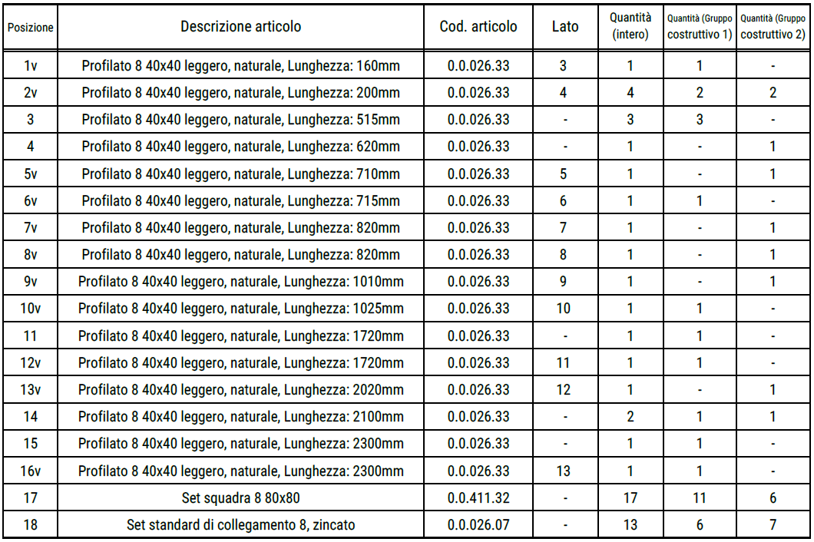

Here is a picture of the final completed construction of the entire structure made of profiles:

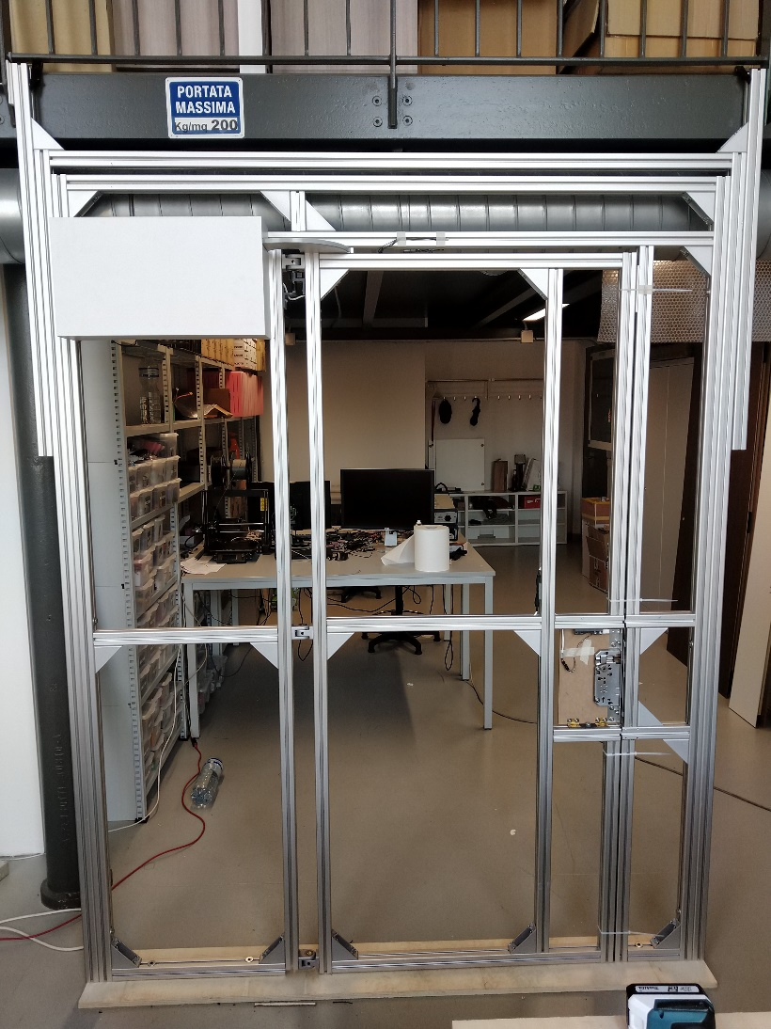

Note the two most external profiles which connect to the ceiling in this picture are used only for structural stability and are not part of the build.

1

2

1: Box with electronics and motor  
2: Load cell and Lock Mechanism

## Handles

There are two type of handles that can be used, lever ones (the one in the picture) and knob ones. They can be replaced at any moment, given a robot is not undergoing the benchmark, by removing the cover panel and unscrewing them like normal handles. The handles can have different colour, texture and shape in order to make every run of the benchmark slightly different. Only one type of knob handle is available, while there are six different types of lever handles (see picture).

## Lock Mechanism

The locking mechanism is a completely standard door lock which holds the door in a closed position and requires the handle to be manipulated in a specific way before it can be opened. In order to measure the forces applied to it, the handle is mechanically connected to the door by a Load Cell (described in the next Section of this document).

## Load Cell

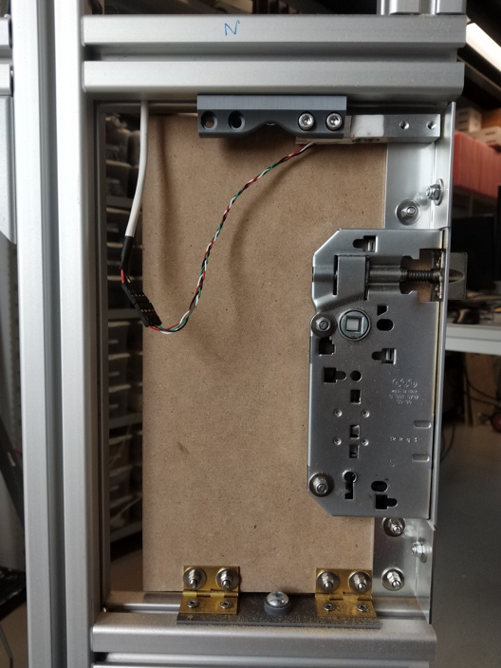A single load cells with a maximum load of 20Kg is mounted on the panel which holds the handle and lock. It is used to register any force applied to the handle by the robot, but also any forces applied around the handle. The load cell is also used to determine whether the door is being pushed or pulled, so the controller knows when to apply a force using the motor.

1

2

1:Load Cell   
2: Lock Mechanism

## Cover Panels

The panels covering the Door Assembly Frame will be white while the door panels will be from of different colours and texture to simulate different doors. One panel for each side of the door makes a total of six to ten panels available. They rest on the horizontal profiles of the door and are kept in position by magnets on both panels, which results in the panels attracting each other and staying in place. This allows a quick and easy replacement of the panels from one test to the next. There are three colours of panels available: light brown, dark brown and white.

3

2

1

## Direction locks

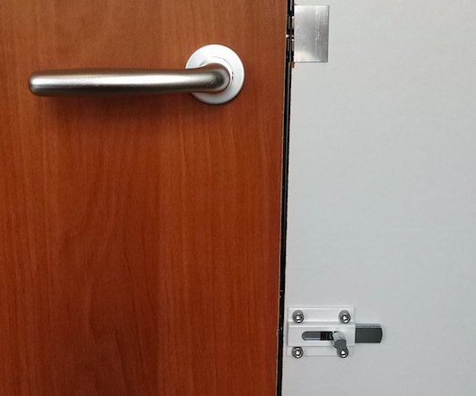Part of the benchmark is testing if the robot can understand in which way the door needs to be opened. Since emulating the behaviour of the mechanical end stop of a conventional door (the protruding elements that, by engaging with the frame, prevent the door from going further than its “closed” configuration) with the use of the motor led to results that did not match accurately enough the real behaviour of a door, two sliding locks have been installed per side of the door. Sliding one in the locked position will prevent the door from opening in that direction. Since these can be used by the robot to understand where the door must be opened, they were coloured white to hide them as much as possible in the white cover panel.

1: Direction Lock

1: Box containing the electronics and motor

2: White cover panels

3: Door Panel

1

## Motor and Gear

The motor is a direct current motor with max voltage and ampere input of 48 V and 10 A. The gear is circular with teeth on the side opposite with respect to the position of the motor, its diameter is 300 mm. A hole was cut in the middle to allow the profile to attach to the top of the structure in order to give a better geometry and sturdiness. A belt connects these two elements and the reduction from gear to motor is 1:10. The motor itself has a 4:3 reduction.

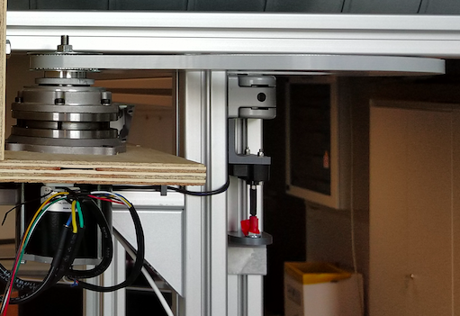

3

2

1

1: Motor  
2: Belt  
3: Encoder

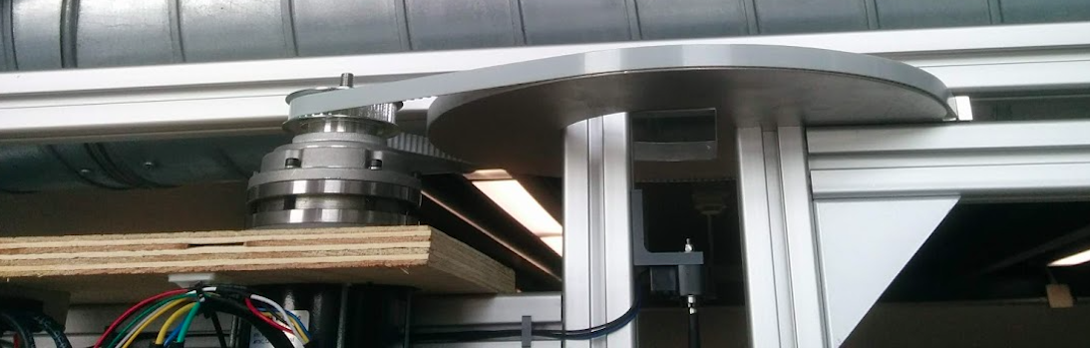

3

2

1

1: Motor  
2: Gear  
3: Belt

## Electronics

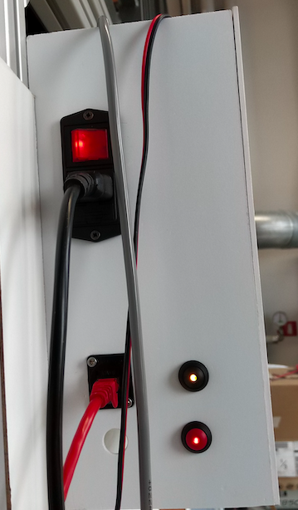All the computation needed for the execution of the benchmarks is done with a Raspberry PI 3 and a Vesc Field[2] Oriented Controller, all attached to the structure close to the electric motor (Picture in the next page). The Pi is running a Linux distribution with ROS. The Vesc six[3] used is a general-purpose motor controller which can run the motor in FOC mode. This allows for a smooth control of the torque applied to the door by the motor by modifying the current that goes in the motor. All the computing parts and the motor are contained in a white box on the side wall of the door. This box has a power rocker switch, an ethernet port for connection to the Pi, a power inlet for 230 VAC and two physical buttons, one red and one black.   
The red button is used to switch between:

2

1

1: Black Button  
2: Red Button

* Look Up Table (LUT) controller
* No controller for the door.

The red button has a led which will give information on the state of the controller:

* no light means disabled controller (the door is free)
* fixed red light means LUT controller is being used
* slow flashing is fixed setpoint break
* fast flashing is KT calibration mode.

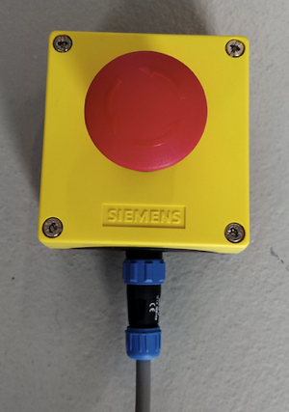In Look Up Table mode the controller will read the angle from the encoder and apply a torque based on the contents of a table. In no Controller mode, the door is free to be moved with no torque. Setpoint break is used to apply the defined current to the motor in order to generate a breaking torque, while KT calibration is the mode used to start the calibration process for the motor. This process uses data acquired from applying a current ramp to the motor to calculate the value of the KT constant. This constant is used to compute the required current to obtain a specified torque on the door handle. More information on these modes of operation and calibrations can be found in the section 2 of this document.   
The black button in the other hand is used to reset the zero angle of the encoder, the angle at which the door is considered closed. This operation must be executed only when starting the system for the first time or when calibration of the system is required because of the swapping of a broken part.  
Finally, an emergency red power rocker switch is connected with a 5 m cable under the ethernet port and, if pressed, it will cut current from the controller, which will result in the motor not applying any more torque to the door. This should be used in an emergency when the door is behaving anomaly.   
All the electrical components as well as the motor are powered by a power supply installed in the top of the white box. 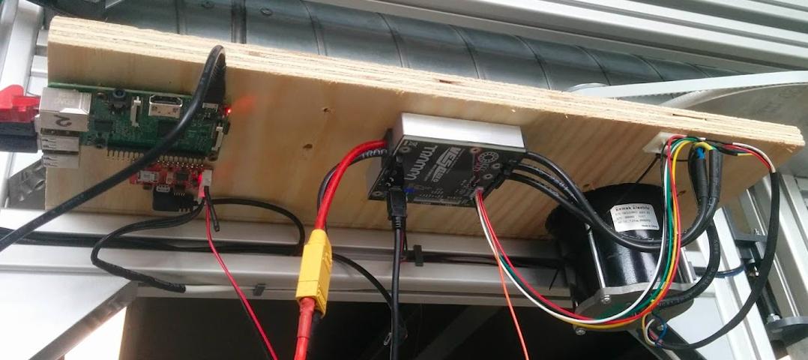

Red power rocker switch

3

2

1

A picture of the electronics without the white box.  
1: Raspberry Pi  
2: Vesc Controller  
3: Bottom part of the motor

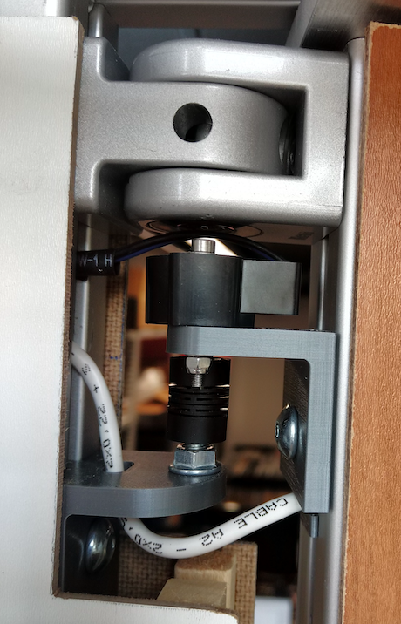

## Encoder

An encoder[4] is connected to the door and, after being calibrated, it is used to feed to the controller the current opening angle of the door. This information is then used by the controller to know when it needs to apply a braking force to the door, by reading a Look Up Table. It is held in place by two 3d-printed supports which lock into the aluminium profiles. The encoder is positioned on the rotating axis of the door hinges in order to record the opening angle of the door. It has a reading frequency of 100 Hz and feeds directly into the Vesc controller used to power the motor. It measures 3600 values per complete circle. Counter clockwise movement of the door is registered as a positive angle while clockwise movements yield a negative angle. It is suggested to calibrate the encoder before every run and the procedure will be explained in the next chapter. On the side there is a picture of the encoder connected to the side of the door and frame.

2

1

2

1: Encoder  
2: 3d-printed supports

## Laser Proximity Sensors

Sixteen laser proximity sensors are mounted on top of the door, four per side of the door. Each sensor measures the distance to the closest obstacle that intersects their cone of vision finds. Each strip has four laser sensors so there will be a total of sixteen sensor looking down on the door. The sixteen sensors are divided into four strips of four sensors each. The strips are identified by their position with respect to the door: two strips are clock-wise named because they are on the clock-wise opening side of the door when looked from above. The other two strips are counter clock-wise named because they are on the counter clock-wise opening side of the door 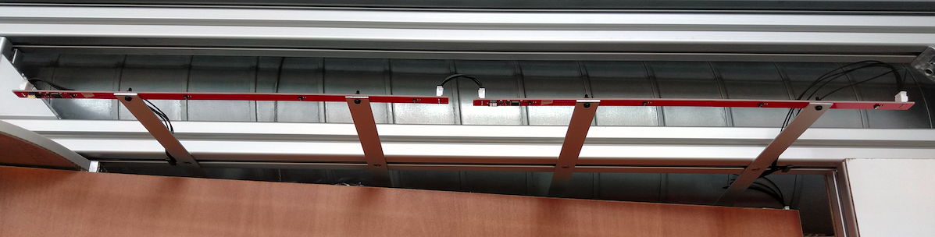when looked from above. While looking at the door, the strips are identified by their side which can be left or right.

Laser proximity sensors on the clock-wise side of the door.   
1: CW Left  
2: CW Right

2

1

## ROS

The communication between the different components of the door is done with Ros. In this section we will describe the topics, services and messages used to transfer information and call services.

### Ros Topics

Here is the complete list of ros topics published by the MADROB testbed:

* /madrob/door/brake_setpoint: This value corresponds to the current setpoint that will be used to brake the door.
* /madrob/door/state: This topic contains all the necessary information about the doors state, the values it contains are:
  + Angle: the current angle of the door, zero is closed, positive angles are counter-clockwise, negative ones are clockwise. This is measured in [rad].
  + velocity: the door’s angular velocity in [rad/s].
  + duty-cycle: normalized current duty cycle from -1 to 1.
  + supply_current: Current drawn from the power supply [A].
  + phase_current: Motor phase current [A].
  + mode: Defines what mode the door is operating in, can be
    - 0 for no control
    - 1 for Look Up Table
    - 2 for fixed setpoint brake
    - 123 for KT calibration mode.
  + state: Indicates the state of the door, can have eight values:
    - 0 for free door
    - 1 for cw LUT
    - 2 for ccw LUT
    - 3 for fixed setpoint brake
    - 4, 5, 6 and 7 are used for KT calibration and represent the following steps of the calibration: initialization, tensioning, current ramp and detensioning. More information in the calibration section 2.1.
  + status: Indicates if the controller is connected
* /madrob/door/handle/state: this topic records the state of the load cell of the handle and contains four important values:
  + force: the force read by the load cell, positive if pushing towards positive angle, negative otherwise. The measurement unit of this value is defined during the calibration process (see section 2.1). Based on that measurement unit, all forces will be reported in that measurement unit after the calibration .
  + kappa: Inclination of the line calculated during the calibration of the load cell, measures [force/ADU].
  + offset: second load cell calibration constant, measures the offset of the calculated line, it is measured in [calibration force unit].
  + calibration_status: identifies the current state of the calibration process
    - 0 for first point calibration
    - 1 for second point calibration
    - 2 for offset calibration
    - 3 for no calibration
* /madrob/passage/ccw_left
* /madrob /passage/ccw_right
* /madrob/passage/cw_left
* /madrob/passage/cw_right: all passage topics have a value called status_ok to confirm the proximity sensors are working correctly and then four values which measure the distant the laser sensor sees to the first obstacle in [mm].

### Ros Services

Here is a list of all services and a brief explanation:

* /madrob/door/calibrate_position: Used in the door encoder calibration, requires three runs, one for each of the values it can receive:
  + 0: The door is in the zero position, meaning it is closed. This resets the zero of the door and as previously stated, it can also be done by using the black button on the back of the door.
  + 1: The door is in the maximum clockwise position, which means it is completely open towards the side of the box with the electronics.
  + 2: The door is in the maximum counter-clockwise position, completely open towards the side opposite to the electronic box.

More information about encoder calibration can be found in section 2.1.3.

* /madrob/door/set_brake: Used to set the type of braking of the motor through the controller. The values it can have are:
  + 0: no brake at all.
  + 1: braking using the Vesc predefined function, needs a current used to brake.
  + 2: handbraking done with the vesc, it differs from previous by using all the current to try and brake.
  + 3: the default brake which uses a PID with speed set to zero.
  + 4: vesc rotor lock, which reads the position of the rotor and tries to keep it still.
* /madrob/door/set_force_calibration: Once the calibration on the motor is done, this service is used to save the KT value obtained.
* /madrob/door/set_lut: asks for the 181 values that form the Lut that will be used by the controller to impose a force on the handle. Type can have two values:
  + 0: for ccw angles
  + 1: for cw angles
* /madrob/door/set_mode: sets the type of controller of the door and can have four different values:   
  0: no control on the door.  
  1: LUT control.  
  3: fixed setpoint brake.  
  123: starts the process used for KT calibration.
* /madrob/door/set_position_calibration: used in manual encoder calibration process, requires three values expressed as duty cycles of the encoder:
  + cw: the max duty cycle in cw position.
  + ccw: the max duty cycle in ccw position.
  + zero: the value of duty cycle with closed door.
* /madrob/door/handle/calibrate: used in the load cell calibration, requires three parameters:
  + Sample: the number of readings it will do in one second.
  + Step: calibration of the load cell is done with the use of a line, so two points are needed to calculate said line. Step can have value
    - 0: corresponds to the lowest value which will be used to calibrate
    - 1: the highest value.
  + Force: the last value is the force which is being applied to the handle. It does not have a measurement unit but all other forces reported by the system in future will use the same measurement unit as the one used to calibrate here, so if 2000 (grams) is used as the force every future measurement of the force value will be in grams.
* /madrob/door/handle/set_calibrate: used to manually set the two values obtained in the handle calibration process:
  + Gain (force/ADU)
  + Offset (force).

More details on the calibration process for handle, encoder and motor is present in chapter 2.1 .

# User guide

In this section all the necessary information to operate the Hinged Door will be explained. All the software and hardware details on how the benchmark is executed, recorded and finished will be present here. After a chapter on calibration, five example benchmarks are considered and how to start them will be described. The first step in every single benchmark is to make sure there is no controller active on the door. To do so press the red button on the electronics box at the back of the door. This will switch mode to no controller and now operations on the door are safe. Also turning of the power to the controller by either pushing the power rocker switch or turning off the power supply are good choices to prevent the door from moving.

## Calibration

Calibration is the step necessary to guarantee the correct readings from encoder, load cell and controller:

* Handle load cell needs to be calibrated not to read the its own weight and the one of the structures it is attached to, but only to read external forces. This is done through the use of a line, the two values we need to calibrate the load cell are Gain [ADU/force] and the Offset[force]
* Since the encoder has 360 degrees that can be read, it is necessary to set the zero position before its readings can be used by the controller. In this way further readings of the door will be from -90 degrees to +90 degrees.
* The controller needs to know how much current applied to the motor will result in how much torque in the handle. This is done by the computation of a constant called KT.

For these reasons, calibration is a crucial process that is already performed and the door comes with all the correct constants saved (Gain, Offset, Zero and KT). There may be cases in which such calibration must be done from scratch because of some components needing to be replaced. The critical elements that require calibration they are replaced are: motor, load cell, encoder, gear and belt. Also, if a new element has a weight different from the one that was replaced or if any reading from the sensor are not in line with empirical predictions it is suggested to recalibrate.  
This is how the process of calibration must be executed. There are three elements that need to be calibrated. A description of all ROS services used and the values they require is in Chapter 1.13.

### Load Cell Calibration

The first element requiring calibration is the load cell reading the forces on the handle (see section 1.6). To calibrate the load cell, we need to call the ROS Service calibrate, which is done with the command “rosservice call /madrob/handle/calibrate” (See section 1.13.2 for a description of the values required) which will ask for three parameters:

* Sample: the suggested value is 160.
* Step: 0 or 1 depending on which of the two calibration phases are being executed.
* Force: Suggested to use a 2000 g weight but any other weight can be used.

For load cell calibration the door can be in any position but it must be unable to move. Any weight can be used but the value of the weight must be used when calling the service calibrate. This will assure that the load cell is calibrated on that measurement unit and every future measurement of force will be done in that measurement unit. Since forces on the handle are considered positive when they push the door towards increasing angles, the suggested calibration is as follows:

1. Hang a 2kg weight on the clockwise side of the door
2. Execute command: rosservice call /madrob/handle/calibrate sample 160 step 0 force -2000  
   This will set grams as the standard measuring units for weight.
3. Wait for confirmation message.
4. Move the 2 kg weight to the counter-clockwise side of the door
5. Execute command: rosservice call /madrob/handle/calibrate sample 160 step 1 force 2000.
6. Wait for confirmation message.
7. Check values of Gain and Offset by executing command rosstopic echo /madrob/handle/state  
   They are already saved at this point.

The chosen weight is 2 kg but any other weight lower than 20 kg (max of the load cell could be used).

### Motor Calibration

The second element that might need to be calibrated is the motor, in particular the value KT, used to set the current necessary to have a determined force on the door handle. To do so, we must run a test and save the values of the handle state and the door state in two separate Ros Bags. Once the Bags are recorded they need to be saved into a csv file and given to a Python Script that will calculate the value of KT. In order to start this process, remove the handles and the door cover panel and attach the door to the assembly frame with the use of the calibration cord. Here are all the steps:

1. Execute command: rosbag record /madrob/door/state /madrob/handle/state.
2. Call the Ros Service: rosservice call /madrob/door/set_mode: 123. Once this command is executed the door controller will start to apply a current ramp to the motor that will try to open the door while the cord keeps it in place. Be careful if the setup was done incorrectly this phase can be dangerous.
3. Record the values in a csv file, run rostopic echo -b data.bag -p /madrob/door/state > door.csv and rostopic echo -b data.bag -p /madrob/door/handle > handle.csv
4. Run the python script with input handle.csv and door.csv.
5. Once the python script has computed the KT, save it by calling the service rosservice call /madrob/door/set_force_calibration COMPUTED_KT.

### Encoder Calibration

Finally, the last element that might have to be calibrated is the encoder, in particular resetting the zero position and the clockwise and counter-clockwise maximum duty cycles. The calibration process for the encoder follows these steps:

1. Put the door in the closed position
2. Call: rosservice call /madrob/door/calibrate_position 0
3. Pu the door in the clockwise fully opened position
4. Call: rosservice call /madrob/door/calibrate_position 1
5. Put the door in the counter-clockwise fully opened position
6. Call: rosservice call /madrob/door/calibrate_position 2
7. Check the state of the door by running rosstopic echo /madrob/door/state

## Bagging

Since all possible benchmarks require information from topics to be recorded in a ROS bag, here is how the bagging process is executed:

1. Complete all steps required for the benchmark that needs to be run (See next section).
2. Run the command “rosbag record Madrob/door/state /Madrob/handle/state /Madrob/passage/ccw_right /Madrob/passage/cw_left /Madrob/passage/cw_right”
3. In alternative it is possible to run “rosbag record -a” which records all topics but not all of them might be of interest.

In order to identify bags once the recording process is finished, it is suggested to run the previous command with the modifier “-O FileName.bag” in order to keep every single record well differentiated from the previous one.

## Example Benchmarks

Here is a list of benchmarks that exemplify the kind of real-world situations that the hinged door can emulate. For each benchmark, we provide a description and the process to set up and start them. For simplicity of reading and understanding, LUTs are reported in chapter 2.5 so all referenced LUT are present in the following pages.

### No Lock

This is the simplest benchmark that can be executed by the door. In this situation the door is in closed position, but the lock mechanism only needs to be pushed in order for the door to open, there is no need to manipulate the handle, only push it. To start this benchmark, follow these steps:

1. Remove the handles
2. Remove the cover panels and access the locking mechanism.
3. Turn the lock so that the robot will only need to push the door to open it
4. Reinstall the cover panels and the handles
5. Engage the sliding lock on the side from where the robot is approaching the door and keep the other one unlocked.
6. Start the Ros Bag.

Since no LUT is necessary in this benchmark, the controller can remain in a disable state. Finally, start the bagging process in ros and the benchmark can start when the team and referee are ready.

### Lock Mechanism

This is the average situation in which a door is most of the times found, i.e. closed with the lock engaged: pushing it or pulling it alone will not open it. Manipulation of the handle is required to unlock the door and after it is unlocked the door can be opened using a small force. The required steps for this benchmark are:

1. Remove panels and handles to access the locking mechanism.
2. Make sure the lock is installed in such a way that by simply pushing the door it will not open.
3. Reinstall panels and handles.
4. Engage one of the two sliding locks in order to ensure the door only opens on one direction.
5. Start the Ros Bag.

The default setting is a door that has to be pushed in order to open, but any variation of the sliding locks and internal lock mechanism can be used. In this default setting the lock should prevent the door from being opened when pushed, while the sliding lock should prevent the door from opening when pulled: manipulating the handle will allow the door to be pushed open, but it will never be able to be pulled open. No controller on the motor is needed in this benchmark so there in no need to load a LUT or enable the controller.

### Opening the door against a constant force

This is a more complicated situation that the standard one, which applies a small constant torque corresponding to a 3/4 kilograms max force applied to the handle constantly to the panel. This emulates an object behind the door or an old door that requires more force to be opened. The force will be applied constantly by the motor to the door but will stop once it reaches the full opening of the door. The required steps for this benchmark are:

1. Remove panels and handles to access the locking mechanism.
2. Make sure the lock is installed in such a way that by simply pushing the door it will not open.
3. Reinstall panels and handles.
4. Engage one of the two sliding locks in order to ensure the door only opens on one direction.
5. Set the 5.2 LUT with type 0.
6. Since the force should only be present while opening the door, it is not strictly necessary to set a new LUT with type 1, but it is suggested to do so to replace eventually saved LUTs. The second LUT will be the 5.1 LUT with type 1.
7. Start the Ros Bag.

This benchmark can be altered by setting the force to start not at the very beginning of the opening of the door, but at an arbitrary angle. To do so set the 5.3 LUT with type 0 and 5.1 LUT with type 1.

### Opening the door against a sudden force

This is a variation of the previous test and emulates a little pebble under the door that temporarily blocks it and a considerate force is required to move the door. This is achieved by setting a LUT that has a ramp of forces which start small and grows to considerable forces (like 20 kg). Once a certain angle is passed, the door will become free to be moved with no resistance. The ramp is used both to simulate the pebble getting stuck harder and harder under the door, and also to allow the motor to gradually oppose a greater resistance which prevents the belt from slipping on the motor head or gear. In the direction opposite to the door opening there should be no forces. The required steps for this benchmark are:

1. Remove panels and handles to access the locking mechanism.
2. Make sure the lock is installed in such a way that by simply pushing the door it will not open.
3. Reinstall panels and handles.
4. Engage one of the two sliding locks in order to ensure the door only opens on one direction.
5. Set the 5.4 LUT with type 0.
6. Set the 5.1 LUT of type 1.
7. Start the Ros Bag.

### Opening the door against a moderate wind

Similar situation to the previous one, but a small force is applied to the door simulating a wind pushing against the door. The force in this case is bigger when the door is closed and as the robot pushes the door it becomes lower, since the area exposed to the wind reduces. The required steps for this benchmark are:

1. Remove panels and handles to access the locking mechanism.
2. Make sure the lock is installed in such a way that by simply pushing the door it will not open.
3. Reinstall panels and handles.
4. Engage one of the two sliding locks in order to ensure the door only opens on one direction.
5. Set the 5.5 LUT with type 0.
6. Set the 5.1 LUT of type 1.
7. Start the Ros Bag.

To fully emulate such situation, it would be necessary to make the door move on it’s on if left open, but for safety reason it was decided to only allow the motor to brake the movement of the door and not to move it on his own. For this reason, the second LUT to be loaded is an empty one, where the motor does not do anything, even though the correct simulation would require the door to slowly close by itself. For this load LUT 5.1 with type 1.

## Variance in the Benchmarks

In order to make subsequent runs of the benchmark different from one another, there are several elements of the tests that can be changed. The first one is the handles: changing how the handle look can make it harder for the robot to find it. Since there are seven different types of handles, a robot could find a different one at every run of the benchmark. Also, the shape of the handle can be varied from lever to knob which also requires a different manipulation for the door to be opened. Another element that can be altered is the panels: there are three colours of panels available, light brown, dark brown and white. Since the surrounding panels are white, having a white door paired with a white handle is considered the hardest possible benchmark since it might be difficult for the robot to distinguish the shape of the door and handle. This combination of elements should only be used with robots which have no difficulty in completing the benchmark when other combinations are used. Furthermore, the direction in which the door opens can be changed before a benchmark, this will force robots to try and understand this direction before opening the door. Pushing the door to open it is usually considered an easier test, because when pulling the door, the robot must be careful not to be in the way. Finally, the last element that can vary is the breaking force that the motor applies to the door, which was discussed in the previous chapters.  
To summarize, the easiest test should be: dark brown panel, white handle, no breaking force and pushing the door to open it.   
A hard test might be: all white elements with a heavy braking force and a pulling door.  
Given all these variations of the test, teams cannot write a specific behaviour for the robot to follow and the robot’s artificial intelligence is challenged every time it undergoes the benchmark.

## LUTs

In this chapter some suggested LUTs are reported in order to have a list of tables that can be used to set the benchmark and to allow for a better reading of the previous chapters where long list of numbers would only be cumbersome. All following LUTs are reported with type 0, which means they should be used when opening the door in a clockwise fashion. Non-symmetrical LUTs must be modified in order to convert them to type 1. This conversion is done by writing the numbers in the opposite direction.

### No Force LUT

A LUT which does not apply forces, this can also be achieved by disabling the controller:  
“0.0, 0.0, 0.0, 0.0, 0.0, 0.0, 0.0, 0.0, 0.0, 0.0, 0.0, 0.0, 0.0, 0.0, 0.0, 0.0, 0.0, 0.0, 0.0, 0.0, 0.0, 0.0, 0.0, 0.0, 0.0, 0.0, 0.0, 0.0, 0.0, 0.0, 0.0, 0.0, 0.0, 0.0, 0.0, 0.0, 0.0, 0.0, 0.0, 0.0, 0.0, 0.0, 0.0, 0.0, 0.0, 0.0, 0.0, 0.0, 0.0, 0.0, 0.0, 0.0, 0.0, 0.0, 0.0, 0.0, 0.0, 0.0, 0.0, 0.0, 0.0, 0.0, 0.0, 0.0, 0.0, 0.0, 0.0, 0.0, 0.0, 0.0, 0.0, 0.0, 0.0, 0.0, 0.0, 0.0, 0.0, 0.0, 0.0, 0.0, 0.0, 0.0, 0.0, 0.0, 0.0, 0.0, 0.0, 0.0, 0.0, 0.0, 0.0, 0.0, 0.0, 0.0, 0.0, 0.0, 0.0, 0.0, 0.0, 0.0, 0.0, 0.0, 0.0, 0.0, 0.0, 0.0, 0.0, 0.0, 0.0, 0.0, 0.0, 0.0, 0.0, 0.0, 0.0, 0.0, 0.0, 0.0, 0.0, 0.0, 0.0, 0.0, 0.0, 0.0, 0.0, 0.0, 0.0, 0.0, 0.0, 0.0, 0.0, 0.0, 0.0, 0.0, 0.0, 0.0, 0.0, 0.0, 0.0, 0.0, 0.0, 0.0, 0.0, 0.0, 0.0, 0.0, 0.0, 0.0, 0.0, 0.0, 0.0, 0.0, 0.0, 0.0, 0.0, 0.0, 0.0, 0.0, 0.0, 0.0, 0.0, 0.0, 0.0, 0.0, 0.0, 0.0, 0.0, 0.0, 0.0, 0.0, 0.0, 0.0, 0.0, 0.0, 0.0, 0.0, 0.0, 0.0, 0.0, 0.0”

### Constant force LUT all range

This LUT applies a constant Force in one direction for all the range of the door:   
“4.0, 4.0, 4.0, 4.0, 4.0, 4.0, 4.0, 4.0, 4.0, 4.0, 4.0, 4.0, 4.0, 4.0, 4.0, 4.0, 4.0, 4.0, 4.0, 4.0, 4.0, 4.0, 4.0, 4.0, 4.0, 4.0, 4.0, 4.0, 4.0, 4.0, 4.0, 4.0, 4.0, 4.0, 4.0, 4.0, 4.0, 4.0, 4.0, 4.0, 4.0, 4.0, 4.0, 4.0, 4.0, 4.0, 4.0, 4.0, 4.0, 4.0, 4.0, 4.0, 4.0, 4.0, 4.0, 4.0, 4.0, 4.0, 4.0, 4.0, 4.0, 4.0, 4.0, 4.0, 4.0, 4.0, 4.0, 4.0, 4.0, 4.0, 4.0, 4.0, 4.0, 4.0, 4.0, 4.0, 4.0, 4.0, 4.0, 4.0, 4.0, 4.0, 4.0, 4.0, 4.0, 4.0, 4.0, 4.0, 4.0, 4.0, 4.0, 4.0, 4.0, 4.0, 4.0, 4.0, 4.0, 4.0, 4.0, 4.0, 4.0, 4.0, 4.0, 4.0, 4.0, 4.0, 4.0, 4.0, 4.0, 4.0, 4.0, 4.0, 4.0, 4.0, 4.0, 4.0, 4.0, 4.0, 4.0, 4.0, 4.0, 4.0, 4.0, 4.0, 4.0, 4.0, 4.0, 4.0, 4.0, 4.0, 4.0, 4.0, 4.0, 4.0, 4.0, 4.0, 4.0, 4.0, 4.0, 4.0, 4.0, 4.0, 4.0, 4.0, 4.0, 4.0, 4.0, 4.0, 4.0, 4.0, 4.0, 4.0, 4.0, 4.0, 4.0, 4.0, 4.0, 4.0, 4.0, 4.0, 4.0, 4.0, 4.0, 4.0, 4.0, 4.0, 4.0, 4.0, 4.0, 4.0, 4.0, 4.0, 4.0, 4.0, 4.0, 4.0, 4.0, 4.0, 4.0, 4.0”

### Constant force LUT sudden

This LUT applies the same force as before but at an angle and not at all the range of the door:  
“0.0, 0.0, 0.0, 0.0, 0.0, 0.0, 0.0, 0.0, 0.0, 0.0, 0.0, 0.0, 0.0, 0.0, 0.0, 0.0, 0.0, 0.0, 0.0, 0.0, 0.0, 0.0, 0.0, 0.0, 0.0, 0.0, 0.0, 0.0, 0.0, 0.0, 0.0, 0.0, 0.0, 0.0, 0.0, 0.0, 0.0, 0.0, 0.0, 0.0, 0.0, 0.0, 0.0, 0.0, 0.0, 0.0, 0.0, 0.0, 0.0, 0.0, 0.0, 0.0, 0.0, 0.0, 0.0, 0.0, 0.0, 0.0, 0.0, 0.0, 0.0, 0.0, 0.0, 0.0, 0.0, 0.0, 0.0, 0.0, 0.0, 0.0, 0.0, 0.0, 0.0, 0.0, 0.0, 0.0, 0.0, 0.0, 0.0, 0.0, 0.0, 0.0, 0.0, 0.0, 0.0, 0.0, 0.0, 0.0, 0.0, 0.0, 0.0, 0.0, 0.0, 0.0, 0.0, 0.0, 0.0, 0.0, 0.0, 0.0, 0.0, 0.0, 0.0, 0.0, 0.0, 0.0, 0.0, 0.0, 0.0, 0.0, 0.0, 0.0, 4.0, 4.0, 4.0, 4.0, 4.0, 4.0, 4.0, 4.0, 4.0, 4.0, 4.0, 4.0, 4.0, 4.0, 4.0, 4.0, 4.0, 4.0, 4.0, 4.0, 4.0, 4.0, 4.0, 4.0, 4.0, 4.0, 4.0, 4.0, 4.0, 4.0, 4.0, 4.0, 4.0, 4.0, 4.0, 4.0, 4.0, 4.0, 4.0, 4.0, 4.0, 4.0, 4.0, 4.0, 4.0, 4.0, 4.0, 4.0, 4.0, 4.0, 4.0, 4.0, 4.0, 4.0, 4.0, 4.0, 4.0, 4.0, 4.0, 4.0, 4.0, 4.0, 4.0, 4.0, 4.0, 4.0, 4.0, 4.0”

### Sudden ramp LUT

This LUT uses a fast ramp to reach a high opposing force:   
“0.0, 0.0, 0.0, 0.0, 0.0, 0.0, 0.0, 0.0, 0.0, 0.0, 0.0, 0.0, 0.0, 0.0, 0.0, 0.0, 0.0, 0.0, 0.0, 0.0, 0.0, 0.0, 0.0, 0.0, 0.0, 0.0, 0.0, 0.0, 0.0, 0.0, 0.0, 0.0, 0.0, 0.0, 0.0, 0.0, 0.0, 0.0, 0.0, 0.0, 0.0, 0.0, 0.0, 0.0, 0.0, 0.0, 0.0, 0.0, 0.0, 0.0, 0.0, 0.0, 0.0, 0.0, 0.0, 0.0, 0.0, 0.0, 0.0, 0.0, 0.0, 0.0, 0.0, 0.0, 0.0, 0.0, 0.0, 0.0, 0.0, 0.0, 0.0, 0.0, 0.0, 0.0, 0.0, 0.0, 0.0, 0.0, 0.0, 0.0, 0.0, 0.0, 0.0, 0.0, 0.0, 0.0, 0.0, 0.0, 0.0, 0.0, 0.0, 0.0, 0.0, 0.0, 0.0, 0.0, 0.0, 0.0, 0.0, 0.0, 0.0, 0.0, 0.0, 0.0, 0.0, 0.0, 0.0, 0.0, 0.0, 0.0, 0.0, 0.0, 2.0, 2.0, 3.0, 3.0, 5.0, 5.0, 8.0, 8.0, 8.0, 12.0, 12.0, 12.0, 20.0, 20.0, 20.0, 20.0, 20.0, 0.0, 0.0, 0.0, 0.0, 0.0, 0.0, 0.0, 0.0, 0.0, 0.0, 0.0, 0.0, 0.0, 0.0, 0.0, 0.0, 0.0, 0.0, 0.0, 0.0, 0.0, 0.0, 0.0, 0.0, 0.0, 0.0, 0.0, 0.0, 0.0, 0.0, 0.0, 0.0, 0.0, 0.0, 0.0, 0.0, 0.0, 0.0, 0.0, 0.0, 0.0, 0.0, 0.0, 0.0, 0.0, 0.0, 0.0, 0.0, 0.0, 0.0, 0.0”

### Wind Ramp LUT

This LUT will use the following equation to calculate the force needed in each point: since the area of the door on which the force is applied depends on the angle of the door according to the following relationship $A=90 cm*210 cm*cosα$  
 .

Now for the computation of the force the following formula will be used: $F=\frac{1}{2}*ρ*v^{2}*A*C$  
 Where $ρ$ is the air density, $v$ is the wind speed, $A$ is the area calculated previously and $C$ is the dimensional drag coefficient. Finally, since our force is expressed in Kg we need to divide the force by $9,81 m/{s^{2}}$ to obtain the mass. By approximating the values to have no decimals, and assuming a 6 m/s wind, we obtain the following LUT:   
“0.0, 0.0, 0.0, 0.0, 0.0, 0.0, 0.0, 1.0, 1.0, 1.0, 1.0, 1.0, 1.0, 1.0, 1.0, 1.0, 1.0, 1.0, 2.0, 2.0, 2.0, 2.0, 2.0, 2.0, 2.0, 2.0, 2.0, 2.0, 2.0, 2.0, 2.0, 2.0, 2.0, 3.0, 3.0, 3.0, 3.0, 3.0, 3.0, 3.0, 3.0, 3.0, 3.0, 3.0, 3.0, 3.0, 3.0, 3.0, 3.0, 3.0, 3.0, 3.0, 3.0, 4.0, 4.0, 4.0, 4.0, 4.0, 4.0, 4.0, 4.0, 4.0, 4.0, 4.0, 4.0, 4.0, 4.0, 4.0, 4.0, 4.0, 4.0, 4.0, 4.0, 4.0, 4.0, 4.0, 4.0, 4.0, 4.0, 4.0, 4.0, 4.0, 4.0, 4.0, 4.0, 4.0, 4.0, 4.0, 4.0, 4.0, 4.0, 4.0, 4.0, 4.0, 4.0, 4.0, 4.0, 4.0, 4.0, 4.0, 4.0, 4.0, 4.0, 4.0, 4.0, 4.0, 4.0, 4.0, 4.0, 4.0, 4.0, 4.0, 4.0, 4.0, 4.0, 4.0, 4.0, 4.0, 4.0, 4.0, 4.0, 4.0, 4.0, 4.0, 4.0, 4.0, 4.0, 4.0, 4.0, 4.0, 3.0, 3.0, 3.0, 3.0, 3.0, 3.0, 3.0, 3.0, 3.0, 3.0, 3.0, 3.0, 3.0, 3.0, 3.0, 3.0, 3.0, 3.0, 3.0, 3.0, 2.0, 2.0, 2.0, 2.0, 2.0, 2.0, 2.0, 2.0, 2.0, 2.0, 2.0, 2.0, 2.0, 2.0, 2.0, 1.0, 1.0, 1.0, 1.0, 1.0, 1.0, 1.0, 1.0, 1.0, 1.0, 1.0, 0.0, 0.0, 0.0, 0.0, 0.0, 0.0, 0.0”  
Using the two previous formulas we can obtain different LUTs in case this one is not enough of a challenge and since this formulas only take into consideration wind velocity and not wind pressure and the effects it has on doors.

# Links

Item24 website: <https://www.item24.it/>

40mm x 40mm profiles: <https://product.item24.it/en/productdetails/products/construction-profiles-8-1001042794/profile-8-40x40-light-natural-2633/>

Angled Brackets: <https://product.item24.it/en/productdetails/products/angle-bracket-zn-1001046547/angle-bracket-set-8-80x80-41132/>

Head Joints: <https://product.item24.it/en/productdetails/products/standard-fastening-sets-1001012015/standard-fastening-set-8-bright-zinc-plated-2607/>

Vesc Controller: <https://www.trampaboards.com/vesc-6-plus-benjamin-vedder-electronic-speed-controller-p-26762.html>

NovaLabs: <http://www.novalabs.io/>

1. All the profiles described in the following sections are from a producer called item24: <https://www.item24.it/>
2. Vesc Project: <https://vesc-project.com/>
3. Vesc six: <http://www.trampaboards.com/vesc-6-plus-benjamin-vedder-electronic-speed-controller-p-26762.html>
4. Encoder Part Number: PSC360G2-F1P-C0000-ERA360-05K-200